1) The following SELECT statement executes successfully:

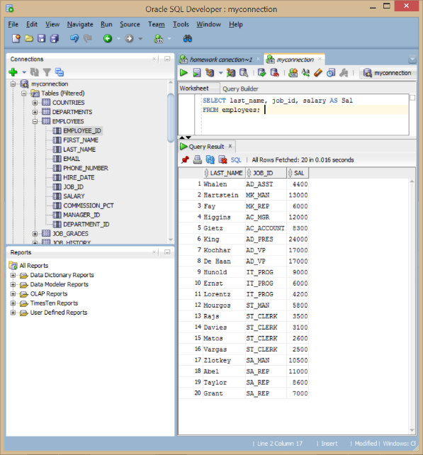True

2) The following SELECT statement executes successfully:

True

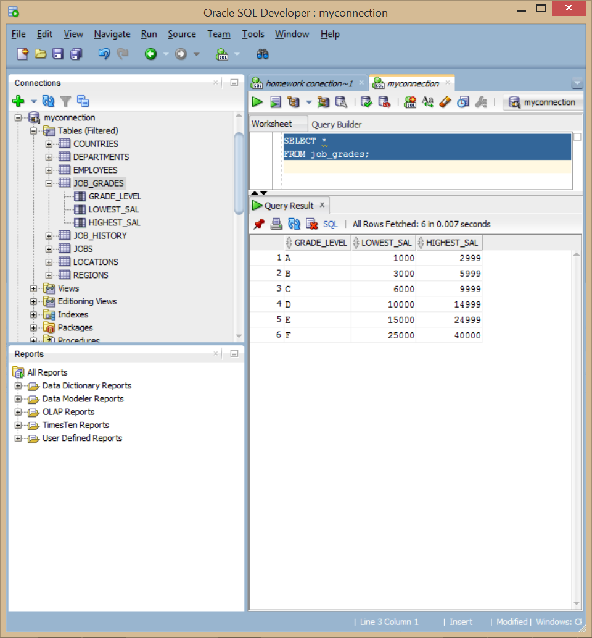

3) There are four coding errors in the following statement. Can you identify them?

SELECT

employee_id, last_name**(needs comma)** sal**(ary)** x**(shoud be a “*”)** 12

ANNUAL**(needs a “_“)**SALARY

FROM employees;

**Correct stamen is as follows**

SELECT

employee_id, last_name, salary*12

ANNUAL_SALARY

FROM employees;

Part 2

4) Your first task is to determine the structure of the DEPARTMENTS table and its

contents.

DESCRIBE departments

SELECT *

FROM departments;

5) Determine the structure of the EMPLOYEES table.

DESCRIBE EMPLOYEES

SELECT employee_ID, last_name, job_ID, hire_date as STARTDATE

FROM EMPLOYEES ;

6) Test your query in the lab_01_05.sql file to ensure that it runs correctly.

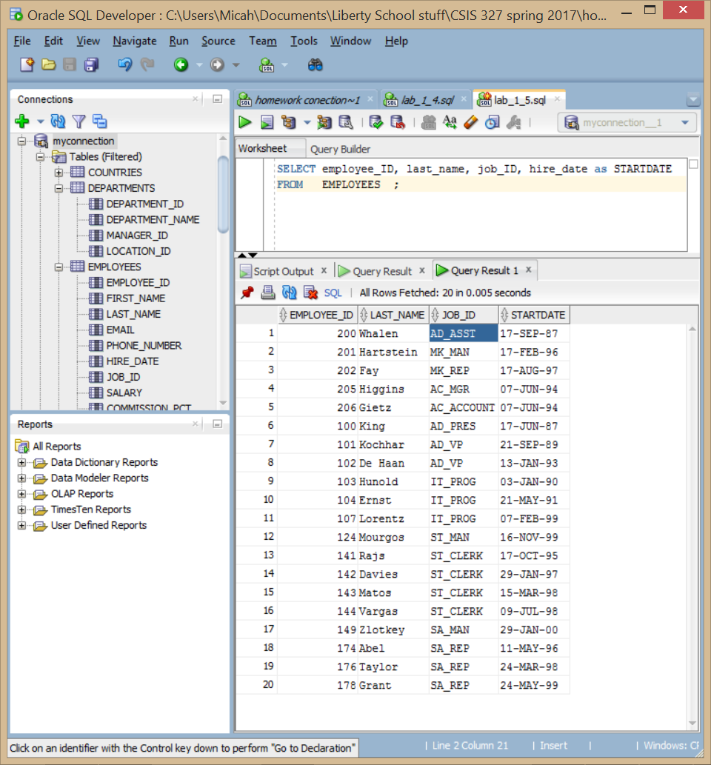

7) The HR department wants a query to display all unique job IDs from the

EMPLOYEES table.

SELECT DISTINCT job_ID

FROM EMPLOYEES ;

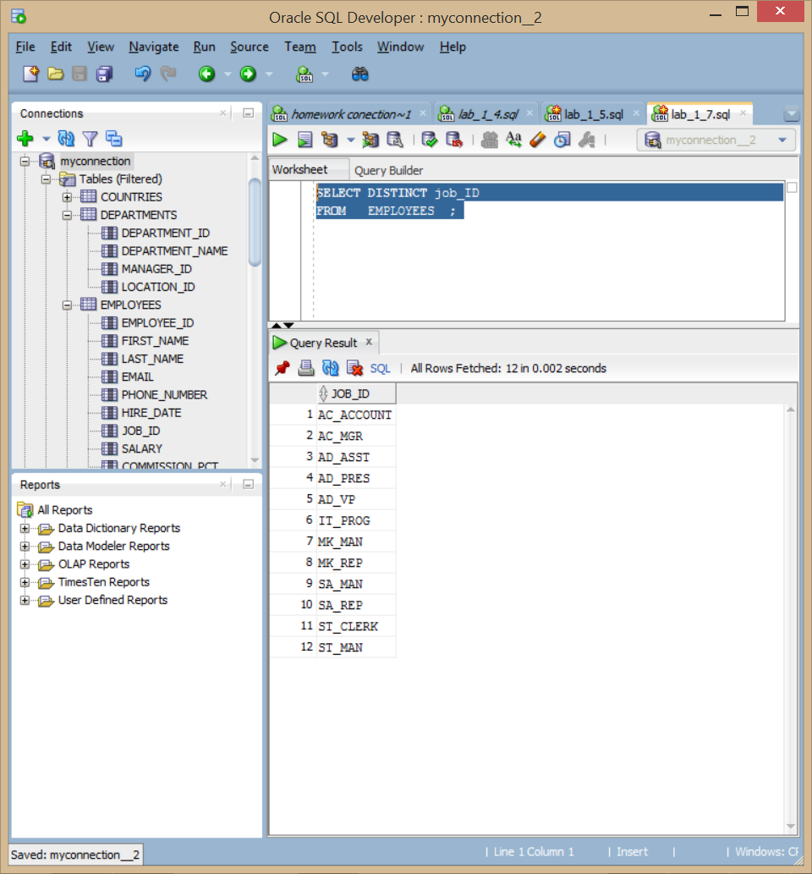

Part 3

8) The HR department wants more descriptive column headings for its report on

employees. Copy the statement from lab_01_05.sql to a new SQL Worksheet. Name the

column headings Emp # , Employee , Job , and Hire Date , respectively. Then run the query

again.

SELECT employee_ID as "Emp #",

last_name as Employee,

job_ID as Job ,

hire_date as "Hire Date"

FROM EMPLOYEES ;

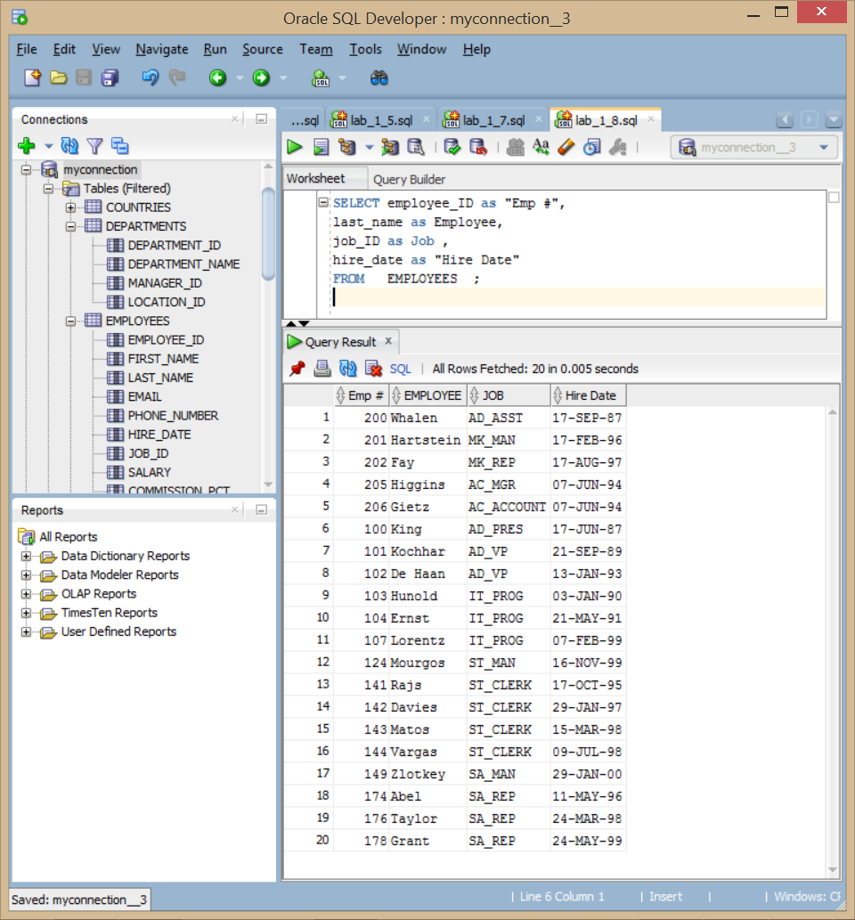

9) The HR department has requested a report of all employees and their job IDs.

Display the last name concatenated with the job ID (separated by a comma and space) and

name the column Employee and Title .

SELECT

last_name ||', '||job_ID "Employee and Title"

FROM EMPLOYEES ;

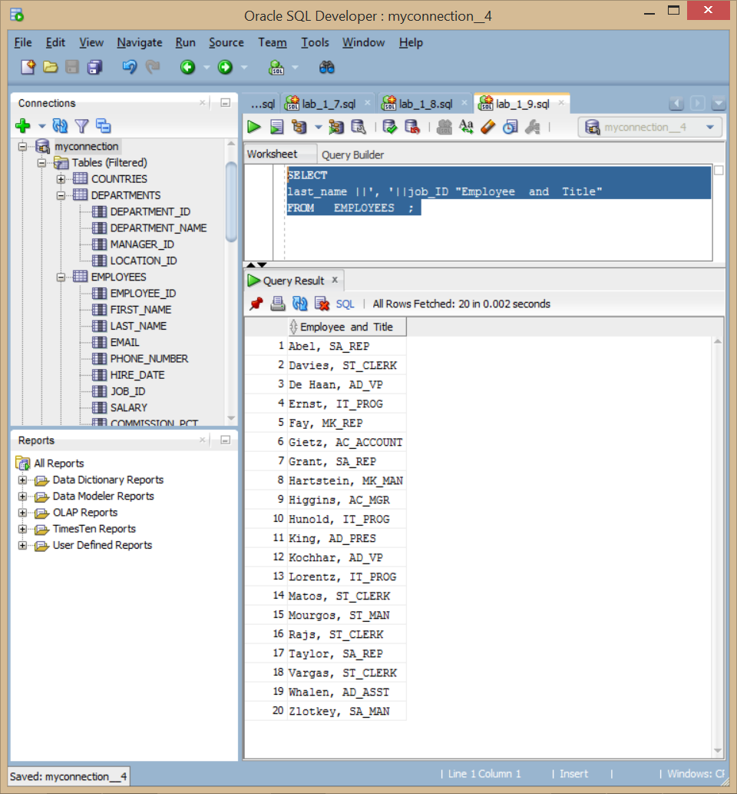

10) To familiarize yourself with the data in the EMPLOYEES table, create a query to

display all the data from that table. Separate each column output by a comma. Name

the column title THE_OUTPUT .

SELECT

EMPLOYEE_ID||','||FIRST_NAME||','||LAST_NAME||','||EMAIL||','||PHONE_NUMBER||','||HIRE_DATE||','||JOB_ID||','||SALARY||','||COMMISSION_PCT||','||MANAGER_ID||','||DEPARTMENT_ID

"THE_OUTPUT"

FROM EMPLOYEES ;

